ME3205
Machine Learning for Engineers

Course Project Report
Machine Learning Approaches for Predicting and Classifying Vehicle CO₂ Emissions

Team:
L. Dharma Teja (SE22UMEE013), K. Srinayanth (SE22UMEE011)
1. Problem Statement
With increasing global emphasis on environmental sustainability, the reduction of vehicular CO₂ emissions has emerged as a critical priority. This project focuses on utilizing supervised machine learning techniques to analyze and predict carbon emissions based on various vehicle specifications. The primary objective is to develop predictive models capable of estimating the actual CO₂ output of vehicles using features such as engine size, fuel consumption metrics, and fuel type.
In addition to emission prediction, the project aims to classify vehicles as either high or low emitters based on a predefined regulatory threshold of CO₂ emissions. This binary classification approach enables the identification of vehicles that exceed acceptable emission limits. To achieve these goals, the project implements and compares the performance of multiple Machine learning models, including Linear Regression, Logistic Regression, and Decision Tree-based methods, in both regression and classification tasks.

2. Methodology
2.1 Data Preprocessing
The dataset used in this study is titled “CO2 Emissions_Canada.csv”, which contains information on 7385 vehicle entries across 12 columns, representing various technical and categorical features related to fuel usage and emissions. This real-world dataset provides a rich basis for both regression and classification tasks.
For the regression analysis, the target variable is CO2 Emissions (g/km) a continuous value representing the amount of carbon dioxide emitted per kilometer by a vehicle. In the case of classification, a new binary label was engineered to categorize vehicles as either compliant (0) or non-compliant (1) with respect to Canadian emission regulations. This classification was based on a threshold of 245 g/km; vehicles emitting more than this threshold were labeled as 1 (high emitters), and those emitting at or below were labeled as 0 (low emitters).
The features selected for model input include both numerical and categorical variables. The numerical features encompass:
- Engine Size (L): the total volume of all the engine's cylinders,
- Cylinders: the number of cylinders in the engine,
- Fuel Consumption City (L/100 km) and Fuel Consumption Hwy (L/100 km): fuel usage rates in city and highway driving conditions respectively,
- Fuel Consumption Comb (L/100 km): a combined average of city and highway consumption, and
- Fuel Consumption Comb (mpg): the same average fuel consumption expressed in miles per gallon, offering an alternative unit for analysis.
In addition to these continuous features, the categorical feature "Fuel Type" which indicates the type of fuel the vehicle uses (e.g., gasoline, diesel, ethanol, natural gas) was included. To incorporate this into the machine learning models, it was one-hot encoded, a technique that converts categorical values into a series of binary columns, allowing algorithms to interpret them numerically without assuming any ordinal relationship.

A correlation heatmap was generated as part of the exploratory data analysis to visualize how strongly each numerical feature correlates with CO₂ emissions. This heatmap revealed high positive correlations between emissions and features like fuel consumption and engine size, validating the selection of these variables for regression and classification models. It also helped identify any redundancy or multicollinearity that could influence model performance.

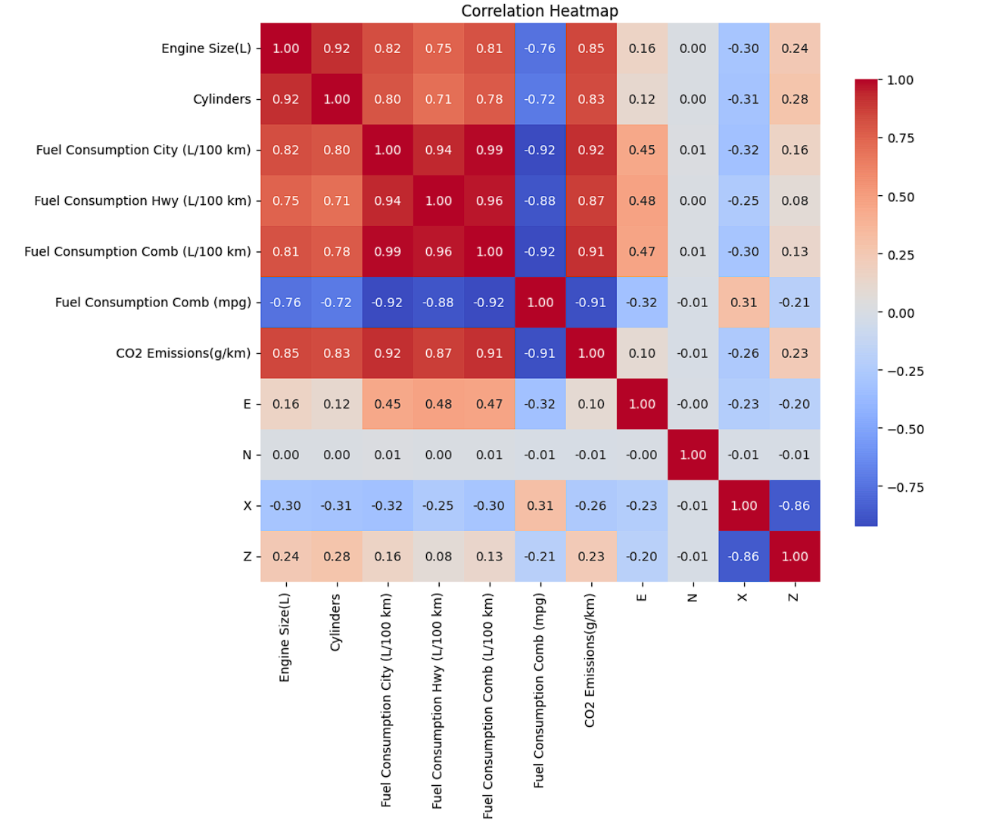
Figure 1 Correlation heatmap of selected numerical features. Darker shades indicate stronger relationships
Finally, the dataset was split into training and testing sets using an 80-20 split. This means that 80% of the data was used to train the models, while the remaining 20% was reserved for evaluating their performance on unseen examples, ensuring a robust and fair assessment of each model’s predictive capability.
2.2 Models Implemented
In this project, we explored multiple supervised learning techniques for both regression and classification tasks on the CO₂ emissions dataset. Each model was chosen based on the nature of the problem whether predicting a continuous variable (regression) or assigning a binary label (classification) as well as interpretability, generalizability, and computational efficiency.
- Linear Regression
- Purpose: Predict the exact value of CO₂ emissions (g/km) from vehicle specifications.
- Why This Model: Linear Regression was selected as a baseline model due to its simplicity, interpretability, and effectiveness when the relationship between features and the target variable is approximately linear. In this dataset, features such as engine size, fuel consumption metrics, and number of cylinders exhibit strong linear correlations with CO₂ emissions, making Linear Regression a suitable starting point.
Steps Involved:
- Selected only numeric features for input (excluding identifiers and string columns).
- One-hot encoded categorical variables like Fuel Type.
- Applied standardization using StandardScaler.
- Evaluation Metrics: MSE, R² score, MAE

- Logistic Regression
- Purpose: Classify vehicles as either compliant (≤ 245 g/km) or non-compliant (> 245 g/km) with emission standards.
- Why This Model: Logistic Regression is ideal for binary classification problems where the goal is to predict probabilities of belonging to one of two classes. In this case, a binary label Legal_Limit was engineered based on the legal CO₂ emissions threshold. Logistic Regression offers not only high performance in linearly separable problems but also clear interpretability through model coefficients.
Steps Involved:
- Created a new target column: Legal_Limit = 1 if CO₂ > 245 g/km else 0.
- One-hot encoded categorical variables and scaled numerical features.
- Trained a Logistic Regression classifier.
- Evaluation Metrics: MSE, R² score, Accuracy, Precision

- Decision Tree Regressor
- Purpose: Predict exact CO₂ emissions values using non-linear relationships.
- Why This Model: Decision Trees are flexible, non-parametric models capable of capturing complex interactions and non-linear dependencies between input features. They are especially useful when interpretability of decision logic is important, and when the relationship between input and output is not strictly linear.
Steps Involved:
- Used the same numeric and encoded features as in Linear Regression.
- Trained a Decision Tree Regressor without pruning.
- Visualized the structure of the tree to interpret splits based on thresholds (e.g., fuel consumption > X)
- Evaluation Metrics: MSE, R² score, MAE

- Decision Tree Classifier
- Purpose: Classify vehicles into compliant/non-compliant classes based on emission limits.
- Why This Model: Decision Tree Classifiers are selected for their intuitive splitting behavior, ease of interpretation, and capability to capture non-linear patterns. Unlike Logistic Regression, they do not assume a linear decision boundary, which can improve performance in cases where relationships are more complex.
Steps Involved:
- Used the same features and Legal_Limit binary label as in the logistic classification task.
- Trained a Decision Tree Classifier on the full dataset.
Analyzed the decision logic using tree visualization to understand how it separates emission classes.
- Evaluation Metrics: MSE, R² score, Accuracy, Precision

3. Results
3.1 Regression Results:
Model | Model Split | MSE | R² Score | MAE
Linear Regression | Train | 35.5499 | 0.9894 | 4.2800
Decision Tree Regressor |  | 157.51 | 0.9542 | 8.5287
Linear Regression | Test | 35.2132 | 0.9901 | 4.2716
Decision Tree Regressor |  | 160.54 | 0.9524 | 8.7192

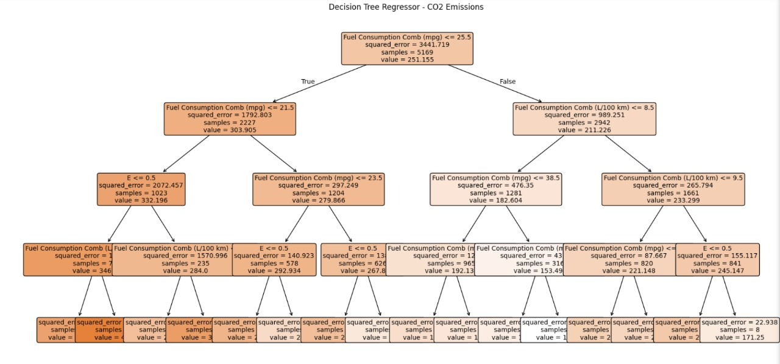
Figure 2 Decision Tree Regressor Structure
3.2 Classification Results:
Model | Model Split | Accuracy | Precision | F1 score | Recall
Logistic Regression | Train | 0.9954 | 0.9969 | 0.9953 | 0.9938
Decision Tree Classifier |  | 0.9740 | 0.9598 | 0.9742 | 0.9890
Logistic Regression | Test | 0.9776 | 0.9986 | 0.9777 | 0.9577
Decision Tree Classifier |  | 0.9715 | 0.9550 | 0.9722 | 0.9901

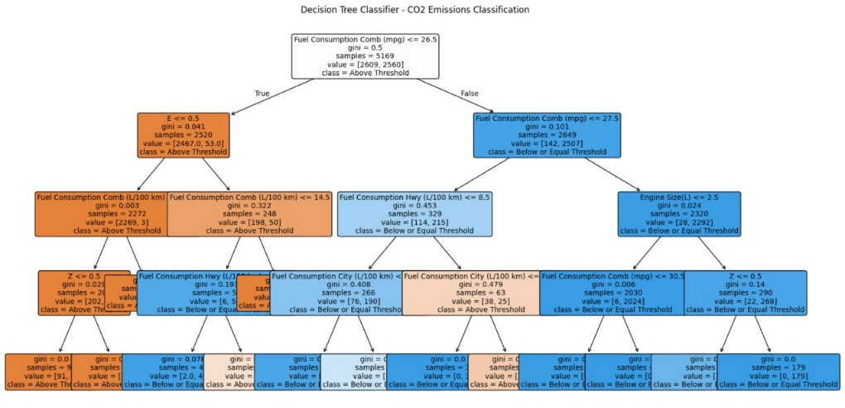
Figure 3 Decision Tree Classifier Structure

- Discussion
3.1 Linear Regression:
The Linear Regression model demonstrated remarkably strong and consistent performance on both the training and testing datasets, confirming its suitability for predicting CO₂ emissions based on the given set of features.

During training, the model achieved a Mean Absolute Error (MAE) of 4.28, a Mean Squared Error (MSE) of 35.5499, and an R² score of 0.9894. These results indicate that the model was able to closely approximate the actual emission values, with an average deviation of less than 5 grams per kilometer, which is excellent considering the range and diversity of the dataset. The high R² score further suggests that nearly 99% of the variance in CO₂ emissions is explained by the model, implying a very strong linear relationship between the selected features and the target variable.

On the testing set, the model maintained its high performance, with an MAE of 4.2716, an MSE of 35.2132, and an R² score of 0.9901. The close alignment between the training and testing metrics is particularly important, as it signifies that the model generalizes well to unseen data and is not overfitting. The minimal difference between training and testing errors confirms the model's robustness and reliability.

The success of the Linear Regression model can be largely attributed to the strong linear correlations between CO₂ emissions and features such as Fuel Consumption (City, Highway, and Combined), Engine Size, and Cylinders, as shown earlier in the heatmap. These variables inherently influence the emissions produced by internal combustion engines, making them highly predictive in a linear modeling context.

Another contributing factor is the preprocessing pipeline. The use of feature scaling and one-hot encoding for the categorical 'Fuel Type' variable ensured that the model could handle both continuous and categorical inputs effectively without introducing bias or scale imbalances.

In conclusion, the Linear Regression model provides a highly accurate and interpretable solution for CO₂ emission prediction. It serves not only as a strong baseline but also as a reliable tool in scenarios where transparency and simplicity are prioritized. Its outstanding performance, combined with minimal variance between training and testing results, reinforces its practical applicability in emission forecasting and policy-oriented environmental analysis.

3.2 Decision Tree Regressor:
The Decision Tree Regressor was applied to predict the CO₂ emissions (g/km) of vehicles based on various technical specifications. As a non-linear, non-parametric model, the decision tree is well-suited to capturing complex relationships and interaction effects between input variables without assuming any functional form.

On the training dataset, the model achieved a Mean Absolute Error (MAE) of 8.5287, a Mean Squared Error (MSE) of 157.5110, and an R² score of 0.9542. These metrics indicate a reasonably good fit to the training data, with the model accounting for approximately 95% of the variance in emissions. The MAE suggests that on average, the model's predictions deviate from actual values by about 8.5 g/km, which, while not negligible, is acceptable in real-world prediction contexts.

Performance on the testing dataset was consistent, with an MAE of 8.7192, an MSE of 160.5426, and an R² score of 0.9524. The close alignment between training and testing results suggests that the model is not significantly overfitting, despite the Decision Tree’s known tendency to overfit when left unpruned. The stability of R² and error metrics across datasets reflects a model that generalizes well to unseen data while maintaining predictive reliability.

Unlike Linear Regression, which assumes additive and linear relationships among predictors, the Decision Tree Regressor splits the data based on feature-specific thresholds, which allows it to model interactions and non-linear patterns. This flexibility is particularly valuable when variables like engine size, fuel consumption, and cylinders combine in non-linear ways to influence emissions.

However, this increased modeling power comes with certain limitations. Decision Trees are inherently prone to creating very specific partitions in the data, which can lead to variance inflation when the structure becomes overly complex. In this case, although the test set results are stable, the relatively high MAE and MSE compared to Linear Regression suggest that some of the tree’s splits may capture local noise rather than generalizable patterns. Pruning or switching to ensemble techniques (e.g., Random Forest or Gradient Boosting) could help mitigate this issue and improve performance further.

In conclusion, the Decision Tree Regressor provided competitive performance, with strong R² scores and acceptable error levels. It is particularly effective for datasets where feature interactions and non-linear boundaries are important. While slightly less precise than Linear Regression in this task, its strength lies in flexibility and transparency of decision logic, which can be valuable in exploratory modeling or when modeling assumptions must be minimal.

Classification Dataset Formation Using Legal Threshold:
To reframe the regression task as a classification problem, a threshold value of 245 g/km was chosen based on regulatory emission standards. A new binary column named Legal Limit was created to label vehicles according to their emission levels. Vehicles with emissions below or equal to 245 g/km were labeled as 0 (compliant), and those with emissions above 245 g/km were labeled as 1 (non-compliant). This binary classification setup allowed models like Logistic Regression and Decision Tree Classifier to be applied effectively. The transformation was executed using the following code:

3.3 Logistic Regression:
The Logistic Regression model demonstrated exceptional performance in classifying vehicles as either compliant or non-compliant with respect to the CO₂ emissions threshold of 245 g/km. The binary label Legal_Limit, derived from this threshold, enabled the application of a supervised classification framework that is both analytically rigorous and environmentally relevant.

During training, the model achieved an accuracy of 99.54%, with a precision of 0.9969, recall of 0.9938, and an F1-score of 0.9953. These results reflect a near-perfect ability to distinguish between high and low emitters. The high precision indicates that almost all vehicles flagged as high emitters were truly non-compliant, minimizing false positives. Simultaneously, the high recall suggests that nearly all actual high emitters were correctly identified, indicating minimal false negatives. The F1-score, which represents the harmonic mean of precision and recall, affirms the model’s balanced and robust performance.

On the test set, the model sustained high performance with an accuracy of 97.77%, precision of 0.9986, recall of 0.9577, and an F1-score of 0.9777. The slight decrease in recall is expected when moving from training to unseen data, but the metrics overall remain exceptionally high. Notably, the precision actually improved on the test set, confirming the model’s reliability in real-world deployment. The consistency between training and testing metrics indicates that the model generalizes well and is not overfitting.

The Logistic Regression model’s success can be attributed to the well-prepared dataset, where strong linear separability exists between the features (such as fuel consumption metrics and engine size) and the emission class labels. Preprocessing steps—such as standardization of numerical features and one-hot encoding of the categorical 'Fuel Type' variable—ensured compatibility with the logistic model’s underlying mathematical assumptions. These steps helped the model form clear decision boundaries between the two classes.

Furthermore, Logistic Regression offers interpretability—feature coefficients can be analyzed to understand which vehicle specifications contribute most to exceeding emissions limits. This characteristic makes the model particularly valuable for policy formulation and regulatory audits, where understanding why a vehicle fails compliance is as important as the prediction itself.

In conclusion, Logistic Regression proved to be a highly accurate, interpretable, and generalizable model for emissions classification. Its combination of statistical rigor and practical reliability makes it an ideal choice for regulatory applications where both precision and recall are of paramount importance.

3.4 Decision Tree Classifier:
The Decision Tree Classifier was implemented to categorize vehicles as either compliant or non-compliant with respect to the regulatory CO₂ emission threshold of 245 g/km, using the binary target variable Legal_Limit. This model is particularly well-suited for classification tasks where interpretability and the ability to handle non-linear relationships are key priorities.

On the training dataset, the model achieved an accuracy of 97.40%, with a precision of 0.9598, recall of 0.9890, and an F1-score of 0.9742. These results indicate that the model performs well in learning complex decision boundaries within the training data. The high recall implies that the model is highly effective in identifying vehicles that exceed the emissions threshold (true positives), while the high precision indicates that most vehicles predicted as non-compliant were indeed non-compliant, minimizing false positives. The balanced and high F1-score demonstrates that the model maintains a strong trade-off between sensitivity and precision.

On the test dataset, the model maintained similarly impressive performance, with an accuracy of 97.16%, precision of 0.9550, recall of 0.9901, and an F1-score of 0.9722. The slight dip in precision and F1-score compared to the training set is minimal and expected when evaluating on unseen data. Importantly, the recall remained extremely high, confirming the model’s ability to consistently detect nearly all high-emitting vehicles in real-world scenarios. This characteristic makes the Decision Tree Classifier particularly valuable in regulatory and environmental compliance contexts, where missing a non-compliant vehicle (a false negative) could be more critical than wrongly flagging a compliant one.

The strength of the Decision Tree Classifier lies in its ability to model non-linear and hierarchical decision structures. It splits the feature space based on thresholds in features like fuel consumption, engine size, and cylinders, which allows it to learn nuanced interactions among variables that may not be captured by linear classifiers. However, this flexibility also introduces the risk of overfitting, especially when the tree becomes deep and overly tailored to training data. In this case, the comparable performance across training and testing sets suggests that the tree depth and structure were well-controlled.

That said, the model could benefit from further optimization techniques such as pruning, setting maximum depth, or transitioning to ensemble methods (e.g., Random Forests or Gradient Boosting) to enhance generalization and reduce sensitivity to data variation. Additionally, feature importance values from the tree offer insights into which vehicle characteristics are most influential in determining emission compliance.

In conclusion, the Decision Tree Classifier provided highly accurate, interpretable, and recall-optimized classification of vehicle emissions compliance. Its balance between flexibility and performance, along with transparent decision logic, makes it a strong candidate for real-world deployment in policy enforcement and automotive sustainability assessments.

- Conclusion
This project explored the application of supervised machine learning techniques to the problem of analyzing and predicting vehicular CO₂ emissions using real-world data. Two primary tasks were addressed: regression, to estimate the actual emission values, and classification, to determine whether a vehicle complies with a defined legal emission threshold.

In the regression task, Linear Regression and Decision Tree Regressor models were implemented. Linear Regression was particularly effective due to the strong linear relationships between the vehicle specifications and the target variable. Its simplicity, interpretability, and low variance make it well-suited for datasets where the underlying patterns are linear. In contrast, while the Decision Tree Regressor can model non-linear dependencies and feature interactions, it is more susceptible to overfitting and tends to show higher prediction variance, especially when not regularized or pruned.

For the classification task, Logistic Regression and Decision Tree Classifier models were used to categorize vehicles as either compliant or non-compliant based on emission thresholds. Logistic Regression performed well in maintaining a balance between sensitivity and specificity, and it is also advantageous for its interpretability and computational efficiency. The Decision Tree Classifier, while effective at capturing complex, rule-based decision boundaries, can be prone to overfitting in some scenarios. However, it excels in interpretability when analyzing feature importance and split logic.

